Anthony Redamonti

Homework 4

First, create a folder in the Desktop named “SimpleScalar” and copy the simplesim-3v0e.tgz, simpletools-2v0.tgz, and simpleutils-2v0.tgz into the folder. Unpack each of them with the following commands:

tar -xvf simplesim-3v0e.tgz

tar -xvf simpletools-2v0.tgz

tar -xvf simpleutils-2v0.tgz

The SimpleScalar folder should look like the below image.

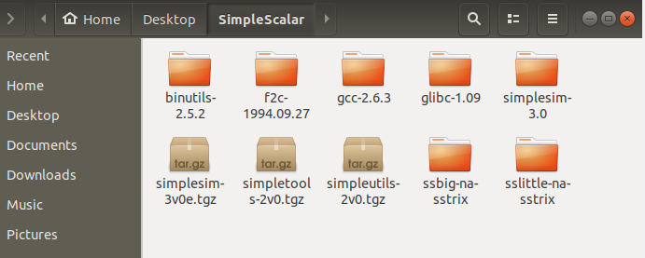

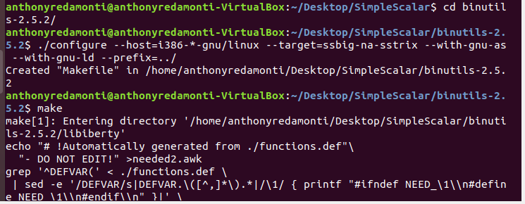

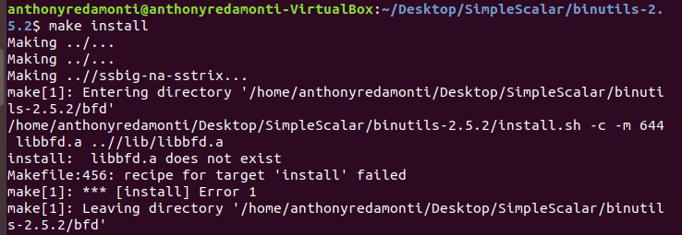

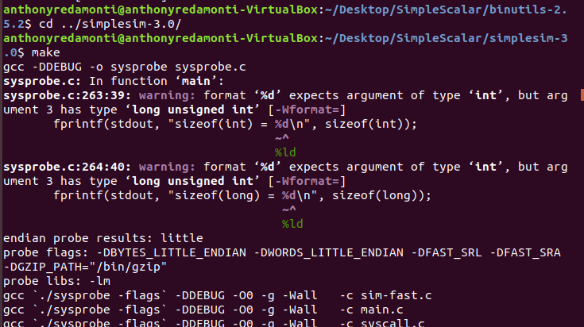

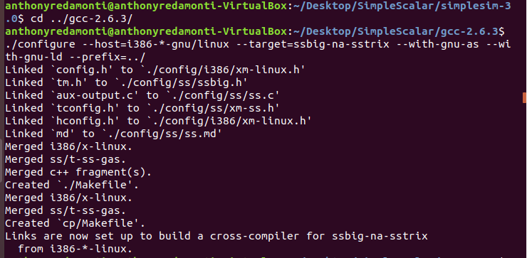

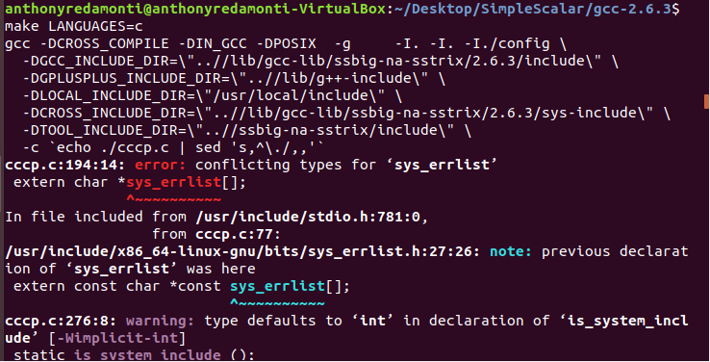

Copy the crt0.o and libc.a files from SimpleScalar/sslittle-na-sstric/ to the following folder: Desktop/SimpleScalar/glibc-1.09.

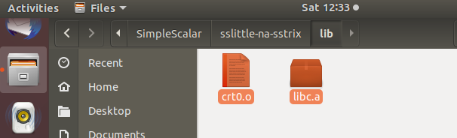

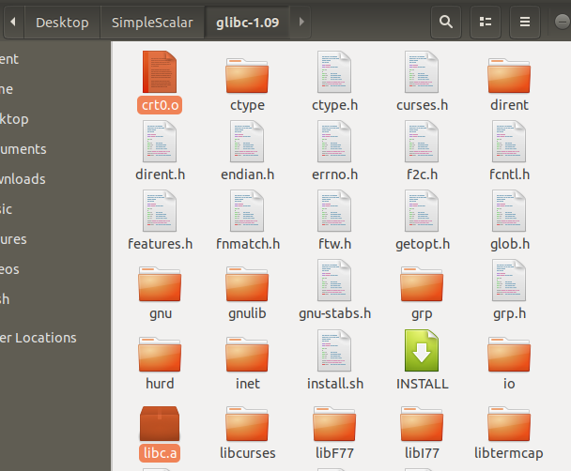

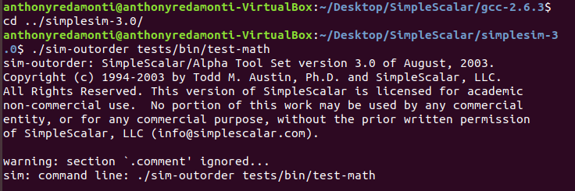

Navigate to the main directory use the ‘cd’ command. For future convenience, create an alias for the file path of the sim-outorder executable.

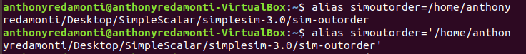

Copy the default.cfg configuration file from simplesim-3.0/config/ into a new directory. Mine is Desktop/Homework4. Rename the copy to NewConfig.cfg. Copy the test-math binary file from simplesim-3.0/tests-alpha/bin/ into the Homework4 folder.

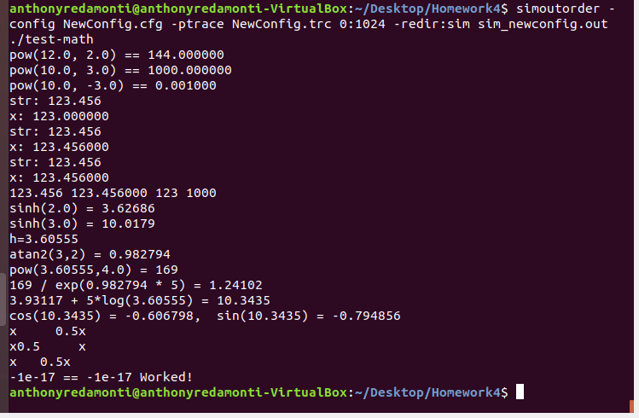

Note the sim_newconfig.out and NewConfig.trc files have been created in the Homework4 folder.

